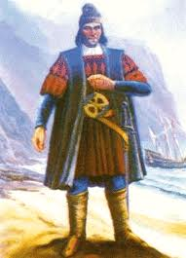
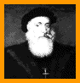
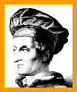
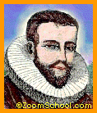
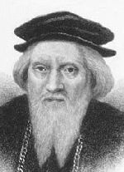
European Explorers
Ponce de Leon | Hernando deSoto | Francisco Coronado | Ferdinand Magellan | Christopher Columbus
Bartolomeu Dias | Vasco de Gama | Amerigo Vespucci | Henry Hudson | John Cabot

