**Map Skills**

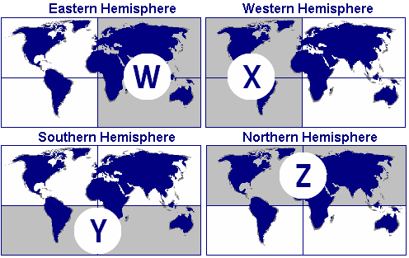

**1. If you were to plot the point 20 degrees south latitude and 40 degrees west longitude, which of the two hemispheres from the provided picture would your point be in?**

1. Z and W B. W and Y C. X and Z D. X and Y

**2. Which of the hemispheres in the provided picture are created by the equator?**

1. Y and W B. Y and Z C. X and Z D. W and X

**3. Which of the hemispheres in the provided picture are created by the Prime Meridian and 180 degree line of longitude?**

1. W and X B. Y and Z C. W and Z D. X and Z

**4. If you were to plot the point 40 degrees north latitude and 20 degrees east longitude, which two hemispheres from the provided picture would your point be in?**

1. W and Z B. Z and X C. Y and Z D. Y and W

**5. What is a line of longitude?**

1. reference line which crosses the globe from east to west
2. reference point which touches each of the continents
3. direct line measuring the distance to the sun from any point on earth
4. reference line which runs from the North Pole to the South Pole

**6. Which of the following is true of the equator?**

1. It is the only line of latitude that runs through all of the continents.
2. It divides the earth into the Eastern and Western Hemispheres.
3. All of the time zones are based off of the equator.
4. It divides the Earth into the Northern and Southern Hemispheres.

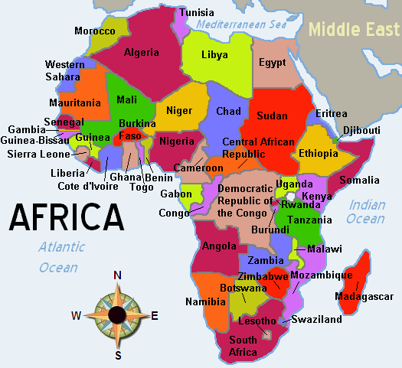

**7. Which of these is southwest of Egypt?**

1. Ethiopia B. Cameroon C. Libya D. Algeria

**8. The island of Madagascar is located off which border of the main continent**?

1. southwest B. northwest C. southeast D. northeast

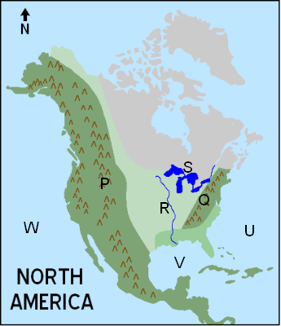

**9. On the map of North America above, which letter marks the Atlantic Ocean?**

A. S B. W C. V D. U

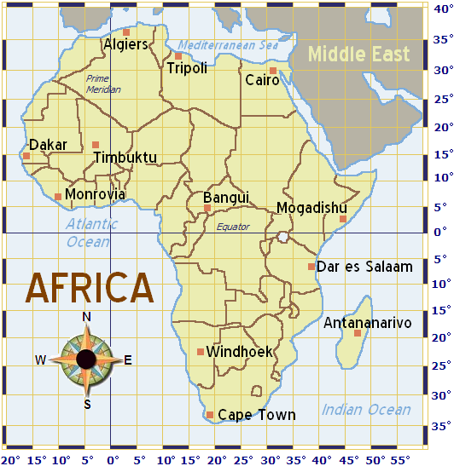

**10. By looking at the map above, which of the following could be the latitude and longitude of Cape Town?**

1. 49 degrees north latitude, 54 degrees east longitude
2. 38 degrees north latitude, 18 degrees east longitude
3. 18 degrees north latitude, 15 degrees west longitude
4. 34 degrees south latitude, 18 degrees east longitude

**11. On the map above, which city is nearest 6 degrees north latitude and 10 degrees west longitude?**

1. Cairo B. Monrovia C. Mogadishu D. Antananarivo

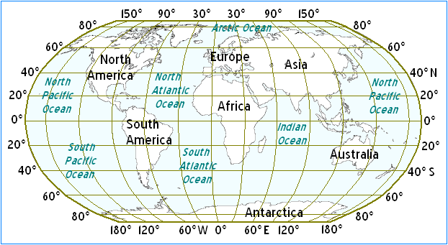

**12. In the map above, through which of the following continents does the equator run?**

1. Antarctica B. Africa C. Europe D. North America

**13. In looking at the map above, through which of the following continents does the Prime Meridian run?**

1. Australia B. Europe C. North America D. South America

**14. Using the picture provided, which of the following locations would be on the equator?**

1. 45 degrees south latitude and 0 degrees longitude
2. 15 degrees north latitude and 45 degrees east longitude
3. 0 degrees latitude and 30 degrees east longitude
4. 30 degrees north latitude and 75 degrees west longitude

**15. What continent would you be on if you traveled to 20 degrees south latitude and 60 degrees west longitude?**

1. Australia B. Africa C. North America D. South America

**16. Which of the following is true of the Prime Meridian?**

1. It's the only point of reference for latitude and longitude on a globe.
2. It divides the Earth into the Northern and Southern Hemispheres.
3. It is equivalent to 0 degrees, east or west, longitude.
4. It is considered to be the center of the Earth

**17. You need to tell your Japanese pen pal where your city is located on the globe. You use your map to help you figure out what to tell him. Which of the following would be helpful in describing your city’s location?**

1. longitude and latitude B. nearby highways C. population D. elevation

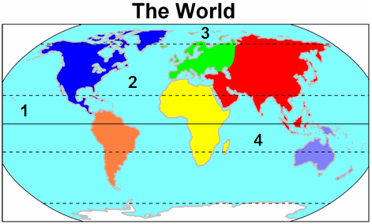

**18. Which ocean is located at number 1 on the map?**

1. Arctic Ocean B. Indian Ocean C. Pacific Ocean D. Atlantic Ocean

**19. This process is the disintegration of rocks, soils, and their minerals through natural, chemical, and biological processes. What is it called?**

1. erosion B. plate tectonics C. weathering D. wind damage

**20. The Earth's shifting surface areas is best described by the theory of**

1. water damage. B. plate tectonics C. weathering. D. erosion.

**21. This process is the movement of soil, mud, rock, and other particles by wind, water, ice, or gravity. What is this called?**

1. erosion B. earthquake C. weathering D. plate tectonics

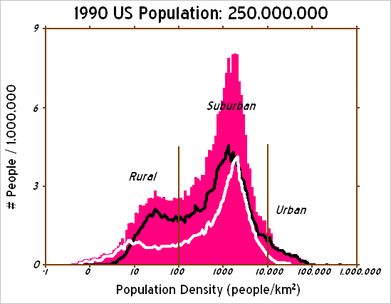

**22. According to the graph, which type of community is most crowded?**

1. suburban B. Each is equally crowded C. rural D.urban

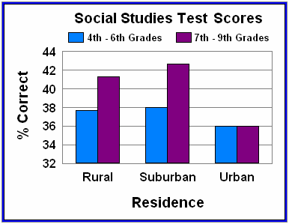

**23. According to the chart, which of these statements is true?**

1. Rural children answered few questions correctly.
2. Suburban teenagers answered fewer questions correctly than suburban fourth graders.
3. Urban seventh graders answered more questions correctly than rural seventh graders.
4. Suburban children answered more questions correctly.

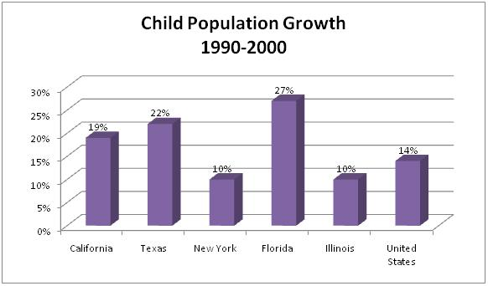

**24. According to the chart, which state has the highest growth in child population?**

1. California B. New York C. Florida D. Texas

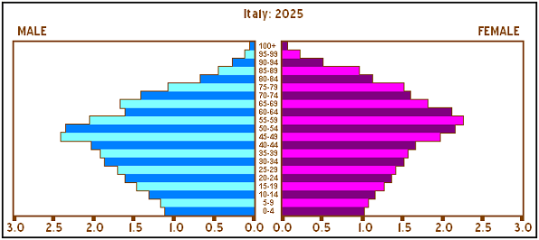

**25. According to the graph, the majority of people in Italy in 2025 will be**

1. males under 30. C. males over 80.
2. between 50 and 60. D. females under 45

**26. In Country A, the elected officials run the government according to a constitution that guarantees the rights and liberties of the citizens. Which of the following best describes the system of government in Country A?**

1. a representative democracy C. a military dictatorship
2. an absolute monarchy D. an aristocracy

**27. Which of the following is an example of U.S. democracy in action?**

1. U.S. companies sell their products in China.
2. The Air Force bombs a terrorist training camp.
3. Your parents vote for your school's tax levy.
4. The police arrest a thief for stealing.

**28. Which of the following is a monarch?**

1. Iraqi President Saddam Hussein C. British Prime Minister Winston Churchill
2. King Louis XIV of France D. General Secretary Joseph Stalin

**29. Which of the following best describes an absolute monarchy**?

1. The king or queen rules by consent of the people.
2. Citizens' rights are guaranteed by a constitution of some sort.
3. A representative parliament is elected by the people.
4. The king or queen has complete authority to rule the country.

**30. In the system of government in Great Britain, Queen Elizabeth II shares power with the British Parliament. What type of government would this be an example of?**

1. communist state C. representative democracy
2. military dictatorship D. constitutional monarchy

**31. Let's say that the people of California are unhappy with one of their senators in Washington. They are upset because he has not done anything he promised to do during the election.**

1. work to get a new senator elected.
2. ask the president to fire the senator.
3. petition to remove the senator from office.
4. march to Washington to protest.

**32. Which of the following is an example of American democracy?**

1. The U.S. Postal Service delivers everyone's mail.
2. A new bill is voted on in Congress.
3. A developer builds a new office building.
4. A student goes to the library to study.

**33. Which of the following is likely to occur in a dictatorship?**

1. Citizens can elect representatives to the government.
2. The government will obey specific limits on its power.
3. The government makes decisions without the consent of the people.
4. The people will be protected by the rule of law

**34. George III was the King of England from 1760 to 1820. As ruler of the British Empire, King George's policies led to discontent in the American Colonies. This discontent sparked the American Revolution in 1776, in which the Americans won their independence from the King's rule.**  **King George III's government was an example of what type of government?**

1. dictatorship B. anarchy C. monarchy D. oligarchy

**35. A dictatorship differs from a democracy because**

1. democracies don't allow people personal freedoms.
2. only one person has power in a dictatorship.
3. democracies rely on birthright when choosing a leader.
4. dictatorships are more common in times of prosperity.

**36. Which of the following is an example of a monarchy?**

1. Elizabeth II is crowned Queen of England in 1952.
2. Bill Clinton is elected president of the United States.
3. Benito Mussolini begins his rule in Italy in 1922.
4. Vladimir Lenin becomes the first leader of the USSR.

**37. Throughout the decade, population shifts within a county may result in unequal population among the various districts. Using the most recent data, district boundaries can be redrawn to equalize population among districts. This concept, known as "one person-one vote," was born out of many 1960s court cases. *www.comptroller.state.tn.us/lg/redist.pdf*  According to the excerpt, what is true about population shifts?**

1. Population shifts keep people from voting.
2. Population shifts can cause redistricting.
3. Only one candidate can run for Congress in a district.
4. Population shifts do not require redrawing districts.

**38. Which political term means to divide a geographic area into voting districts that give an unfair advantage to one party in elections?**

1. population sampling C. jury tampering
2. statutory requirement D. gerrymandering

**39. Stephen Harper is the head of the Canadian government and the leader of the Canadian House of Commons. What is Mr. Harper's title?**

1. Congressman B. Prime Minister C. Dictator D. President

**40. Which one is not one of the five themes of geography?**

A. Place B. Movement C. Distance D. Location

**41. Which continent has the largest population?**

1. Asia B. Africa C. North America D. Australia

**42.** **Sharing information via internet, text messages, and or television are examples of which theme of geography?**

1. Human Environment Interaction B. Location C. Movement D. Place

|  |  |
| --- | --- |
| **C:\Program Files\Microsoft Office\MEDIA\CAGCAT10\j0293238.wmf** | **Handicapped Parking** |
| **C:\Documents and Settings\Student164\Local Settings\Temporary Internet Files\Content.IE5\LSNZE9QG\MC900383850[1].wmf** | **School** |
| **C:\Documents and Settings\Student164\Local Settings\Temporary Internet Files\Content.IE5\598AF3SS\MC900290928[1].wmf** | **Park** |
| **C:\Program Files\Microsoft Office\MEDIA\CAGCAT10\j0293234.wmf** | **Airports** |

**43.** **The image above is an example of ______________.**

1. Compass rose B. scale C. map key D. title

**44. Memphis, Tennessee is an example of which type of community?**

A. urban B. suburban C. rural D. country

**45. During convergent boundaries tectonic plates……..**

A. divide B. collide C. glide D. slide

**46. During transform fault boundaries tectonic plates…..**

A. glide B. divide C. slide D. divide

**47. Latitude and longitude are examples of which theme of geography?**

1. Relative location B. Human Geography C. Movement D. Absolute Location

**48.** **Who is the President of Mexico?**

1. Nestor Kirchner B. Felipe Calderon C. Juan Carlos D. Hugo Chavez

**49.When two continental plates collide with tremendous force, the land along the line rises and forms _______.**

1. Volcanoes B. erosion C. mountains D. tectonic plates

**50. The theory of ________ _________ explains how continents were formed and why they move.**

A. Magma formation B. erosion C. Plate tectonics D. Mantle disbursement

**51. Which political term means to divide a geographic area into voting districts that give an unfair advantage to one party in elections**

A. Statutory requirement C. population sampling

B. Gerrymandering D. jury tampering

**52. Which absolute location would be found in the northern hemisphere?**

A. (23mhtml:file://C:\Documents%20and%20Settings\Student164\Desktop\Discovery%20Education%20Assessment%20%20Probe%201st%20Semester%20Exam.mht!http://pasmedia.discoveryeducation.com/pas/assessments_practice/SS-07/images/degrees_8.gifN, 53mhtml:file://C:\Documents%20and%20Settings\Student164\Desktop\Discovery%20Education%20Assessment%20%20Probe%201st%20Semester%20Exam.mht!http://pasmedia.discoveryeducation.com/pas/assessments_practice/SS-07/images/degrees_8.gifE) B. (23mhtml:file://C:\Documents%20and%20Settings\Student164\Desktop\Discovery%20Education%20Assessment%20%20Probe%201st%20Semester%20Exam.mht!http://pasmedia.discoveryeducation.com/pas/assessments_practice/SS-07/images/degrees_8.gifS, 24mhtml:file://C:\Documents%20and%20Settings\Student164\Desktop\Discovery%20Education%20Assessment%20%20Probe%201st%20Semester%20Exam.mht!http://pasmedia.discoveryeducation.com/pas/assessments_practice/SS-07/images/degrees_8.gifE) C.(48mhtml:file://C:\Documents%20and%20Settings\Student164\Desktop\Discovery%20Education%20Assessment%20%20Probe%201st%20Semester%20Exam.mht!http://pasmedia.discoveryeducation.com/pas/assessments_practice/SS-07/images/degrees_8.gifS, 24mhtml:file://C:\Documents%20and%20Settings\Student164\Desktop\Discovery%20Education%20Assessment%20%20Probe%201st%20Semester%20Exam.mht!http://pasmedia.discoveryeducation.com/pas/assessments_practice/SS-07/images/degrees_8.gifW) D.(54mhtml:file://C:\Documents%20and%20Settings\Student164\Desktop\Discovery%20Education%20Assessment%20%20Probe%201st%20Semester%20Exam.mht!http://pasmedia.discoveryeducation.com/pas/assessments_practice/SS-07/images/degrees_8.gifS, 20mhtml:file://C:\Documents%20and%20Settings\Student164\Desktop\Discovery%20Education%20Assessment%20%20Probe%201st%20Semester%20Exam.mht!http://pasmedia.discoveryeducation.com/pas/assessments_practice/SS-07/images/degrees_8.gifE)

**53. Which of the following is an example of one of the rights that people living in a democracy enjoy?**

A. The right to take someone’s house

B. The right to persecute people from different religions

C. The right to overthrow the government

D. The right to vote in elections

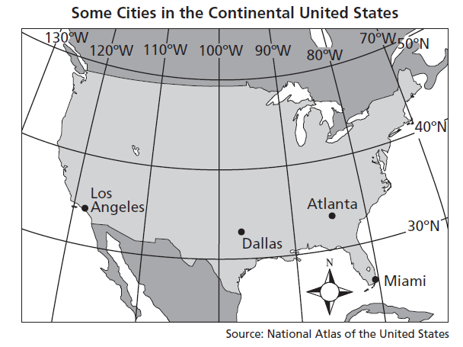

**54. Which city is located nearest 35°N and 80°W on the map above?**

A. Los Angeles B. Dallas C. Atlanta D. Miami

**55. Which city is located nearest 35°N and 118°W on the map above?**

A. Los Angeles B. Dallas C. Atlanta D. Miami

**56. Which city is about 80°W longitude and 26°N latitude?**

A. Los Angeles B. Dallas C. Atlanta D. Miami

**57. Which one describes the closest location to Dallas?**

A. 100°W,90°W B. 30°N, 100°W C.97°W,33°N D. 33°W, 98°

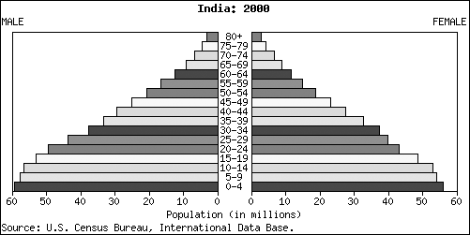

**58. Based on this population pyramid, which of the following is true about India?**

A. There were more males than females ages 15-19

B. There were more females than males ages 15-19

C. The largest number of people in India were over 40 years old.

D. There were more people between the ages of 25-29 than between ages 5-9.

**59. When two continental plates collide with tremendous force, the land along the line rises and forms _______.**

A. Volcanoes B. erosion C. mountains D. tectonic plates

**60. What is true about dictatorships?**

1. They take control of the economy to ensure equal distribution of resources.
2. They rely on a senate to represent the people.
3. They allow free elections to select the next leader.
4. They place governmental power in the hands of one leader.

**61. In which type of government system, do the leaders gain their position because of their parents?**

A. Autocracy B. Democracy C. Monarchy D. oligarchy

**62. The line of latitude closest to the North Pole is**

A. The Tropic of Capricorn C. Antarctic Circle

B. Arctic Circle D. The Tropic of Cancer

**63. On a map with no compass rose, which part of the map is north?**

A. Top B. Bottom C. Left D. Right

**64. The system of government in which an elite group has power is a(n)**

A. Monarchy B. autocracy C. democracy D. oligarchy

**65. Which of these is true about Earth’s tectonic plates?**

A. They are in constant motion. C. They are stable and do no move.

B. They move every hundred years. D. They move suddenly.

**66. In the constitutional monarchy, the power rests with the________________.**

A. president B. monarch C. prime minister D. congress

**67. The ocean between America and Europe is**

A. The Atlantic Ocean C. The Pacific Ocean

B. The Indian Ocean D. The Arctic Ocean

**68. The term subduction refers to**

A. Two plates pushing up to for mountains C. two plates pulling apart.

B. One plate sliding over another plate D. one plate sliding past another plate

**69. What is true about an autocracy?**

A. The head of government inherits the position.

B. The head of government serves for six years.

C. The head of government rules with unlimited power

D. The head of government is limited by checks and balances

**70. A population pyramid is a type of diagram that**

A. shows how different populations compare to each other.

B. shows the ages of all the men and women in a population.

C. only looks at gender and not age

D. only looks at age and not gender

**71. In a constitutional monarchy, the king or queen is**

A. An absolute ruler B. a figurehead C. a prime minister D. a president

**72. Water in a stream slowly wears away at the rock it moves past. This refers to**

A. Earthquakes B. tsunamis C. erosion D. deposition

**73. The U.S. census determines the apportionment of 435 congress people is based on**

A. The performance of congress people in each state.

B. The population of each state as compared to all the states.

C. The popularity of congress people in each state.

D. The wealth of the state as compared to all the states.

**74. Small towns can usually run under a direct democracy government system where every citizen gets a chance to vote on laws and bills. Why would that not work for Memphis?**

A. People in Memphis don’t like to speak face to face

B. People in Memphis prefer a complicated system.

C. People in Memphis speak too many different languages.

D. There are too many people in Memphis for everyone to attend one meeting.

**75. Which part of a map tells you the position of the cardinal directions?**

A. scale bar B. compass rose C. map key D. legend

**76. Senators from Tennessee, like Lamar Alexander serve in Congress for**

A. Four years B. Six years C. Five years D. Two years

**Arctic Circle Antarctic Circle Tropic of Cancer**

**77. What is true about the three locations above?**

A. All 3 are North of the Equator

B. 2 are North of the Equator, and 1 is South of the Equator

C. 2 are South of the Equator, and 1 is North of the Equator

D. All 3 are South of the Equator

**78. The process of the formation and growth of cities is known as which of the following?**

A. Assimilation B. acculturation C. urbanization D. immigration

**79. Which of these are not continents?**

A. North and South America C. Europe and Asia

B. Africa, Australia, and Antarctica D. Russia, Greenland, and China

**80. Refugees are**

A. Internal migrants C. external migrants

B. forced migrants D. voluntary migrants

**81. If limited resources such as food and water supply exist within a country, what is most likely to happen if the population of that country increased over time?**

A. The resources would increase with the size of the population

B. There would be enough resources.

C. The resources would no longer be needed.

D. The resources would be used up and there would be some type of shortage.

**82. Which term refers to the increase in size of a population over a given period of time?**

A. Growth rate B. population C. population density D. family size

**83. Who is the current Prime Minister of India?**

A.Indira Gandhi B. Golda Meir C. Manmohan Singh D. Mahatma Ghandi

|  |
| --- |
| http://pasmedia.discoveryeducation.com/pas/assessments_practice/SS-07/images/poppyrgermany.gif  **84. Study the above population pyramid for Germany. What age group has the largest number of males and females in the population?**  A. 55-59 B. 45-49 C. 30-34 D. 35-39 |
| http://static.discoveryeducation.com/feeds/assessment/10000000-0000-d1d7-e9be-000000000000/10000024120801.gif  **85. According to the chart, which population saw the greatest increase between 1790 and 1800?**  A. Connecticut B. Delaware C. Kentucky D. Maryland  **86. Which state was admitted to the Union after the 1800 census?**  A. Kentucky B. Maine C. Tennessee D. Vermont |
| http://pasmedia.discoveryeducation.com/pas/assessments_practice/SS-07/images/graphtnlargestcitiespop5.gif  **87. Study the above bar graph. Which Tennessee city has the third largest population?**  A. Nashville B. Chattanooga C. Clarksville D. Knoxville  **88. Which of the following would be found on a political map?**  A. deserts, mountains ranges, the locations of rivers.  B. national borders, states boundaries, capitals, and important cities.  C. climate regions and vegetation.  D. natural resources and land use.  **89. A system of government in which each citizen gets to vote on each bill or law is a**  A. representative democracy C. constitutional monarchy  B. oligarchy D. direct democracy  **90. This process is the deciding factor on who wins the presidential race?**  A. popular votes C. Electoral college votes  B. Campaigning D. Running for office  **91. Which two are the symbol and color for the Republican political Party?**  A. donkey, blue B. elephant, red C. donkey, red D. elephant, blue  **92. Memphis is located in the 9th district of Tennessee. Our Congressman’s name is ….**  A. Bob Corker B. Lamar Alexander C. Steve Cohen D. George Flynn  **93. It takes _____________ electoral college votes to become the President of the United States.**  A. 330 B. 370 C. 250 D. 270  **94. This branch of the United States federal government has the power to impeach members of the other branches, make the laws, and override the president’s veto. Which branch of government is this?**  A. executive B. legislative C. judicial D. governors  **95. This tool on a map measures distance from one place to another.**  A. map key B. title C. map scale D. compass rose  **96. The important, imaginary line of latitude that circles Earth along its “shoulders” is the -------**  A. Arctic Circle C. Tropic of Cancer  B. Arctic Circle D. Tropic of Capricorn  **97. This continent has the smallest population.**  A. Europe B. Australia C. South America D. Antarctica  **98. ______________ is the study of the Earth, its surroundings, and its people.**  A. GeographyB. History C. Government D. History  **99. This layer of the Earth’s surface is the thinnest and the continents and oceans sit on it.**  A. core B. mantle C. crust D. shell  **100. Which time zone is Memphis located in?**  A. Pacific B. Mountain C. Eastern D. Central |